**House and Flat Price Prediction Project**

**# Property Type**

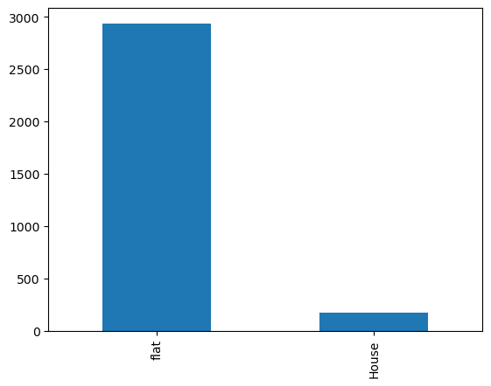

**#** there are more number of Flat as campared to houses in dataset

**Price of property on basis of type vs price_per_sqft**

|  |  |  |  |  |  |  |  |  |  |  |  |  |  |  |  |  |  |  |  |  |  |  |  |  |  |  |  |  |  |  |  |  |  |  |  |
| --- | --- | --- | --- | --- | --- | --- | --- | --- | --- | --- | --- | --- | --- | --- | --- | --- | --- | --- | --- | --- | --- | --- | --- | --- | --- | --- | --- | --- | --- | --- | --- | --- | --- | --- | --- |
| |  | **price1** | | --- | --- | | **society** | **Location** |  | | **Ansal API Esencia** | **Sector 67** | 54600000 | | **Huda** | **Sector 38** | 35000000 | | **IFFCO Nagar and 17B RWA** | **Sector 17** | 35000000 | | **International City by SOBHA Phase 2** | **Sector 109** | 87500000 | | **International City by Sobha Phase 1** | **Sector 109** | 59000000 | | **RWA Sector 46** | **Sector 46** | 45000000 | | **Sector 38 RWA** | **Sector 38** | 14000000 | | **Vipul Tatvam Villa** | **Sector 48** | 76900000 | | **central park resort belgravia residences** | **Sector 48** | 62500000 | | **vipul belmonte** | **Sector 53** | 60000000 | |
|  |

# above graph shows top 10 properties with highest price per sqft of property, its showing property on basis of location and society and its showing the price of property as well

**price vs Property type**

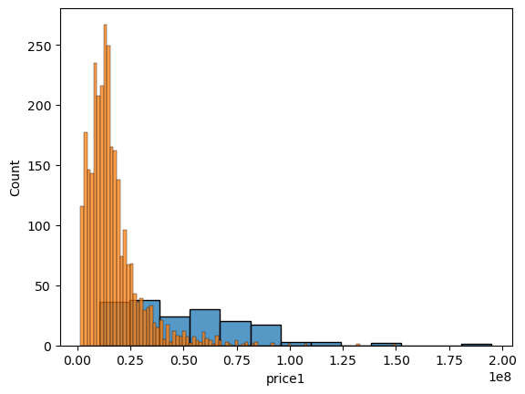

# # in most of bases prices of flat lies between 0.0 to 0.50 and most of house property lies between 0.10 to 0.90

# as per above graph there are some property even exceeeding 1.0 but only few

# thses points can considered to be outliers on basis of some analysis

# price_per_sqft vs property_type

# as per above graph, house property datapoints are even at different scale, in case of flat most of data points lies between 4600 to 20000

# there are only few flat property exceeding 20000

# # bedRoom vs property_type

# # bathroom vs Furnished and luxury_score

# Impact of other fetures on Price[¶](http://localhost:8888/notebooks/model%20building%201/housing%20project/EDA.ipynb#Impact-of-other-fetures-on-Price)

# bedRoom vs Price

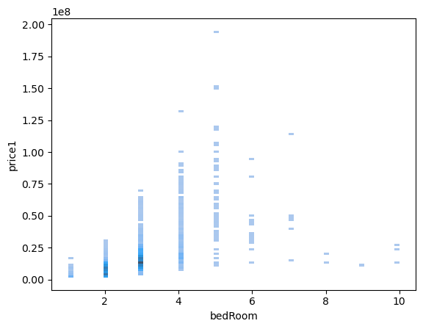

# there is sort of linear relationship between bedRoom and Price but to some extent, when no of bedrom increasing more than 6 then there is no linear relationship but it is upto 6 bedroom

# bathroom vs Price

# there is sort of linear relationship between bathroom and price, but still there are some outliers.

# balcony vs Price

# 

# # there is sort linear realyionship between balcony and Price columns, with increase in balcony, price of property is increasing if we remove outliers from this column

# floorNum vs Price

# # floorNum column can not be used for prediction of price of house because of non linear relationship between floorNum and price

# luxury_score vs price1

# in case of luxury_score column, there is no linear relationship between luxury_score and Price, so it will not proven to be good predictor, there is not any sepecific pattern in data points for prediction of house price

# Build vs price1

# there is linear relationship between Build and price, so it will be good predictor for price but still there are some outliers

# distribution of data is little right skewed

# carpet12 vs Price

# # there is linear realtionship between carpet12 and price, and the distribution of data is right skewed

# Super_area vs price

# distribution of data is right skewed and there is linear relationship between Super_area and price

Final Report

# there are more number of Flat as campared to houses in dataset

# in most of bases prices of flat lies between 0.0 to 0.50 and most of house property lies between 0.10 to 0.90

# as per above graph there are some property even exceeeding 1.0 but only few

# thses points can considered to be outliers on basis of some analysis

# as per above graph, house property datapoints are even at different scale, in case of flat most of data points lies between 4600 to 20000

# there are only few flat property exceeding 20000

# Bedroom vs Price:

# there is sort of linear relationship between bedRoom and Price but to some extent, when no of bedrom increasing more than 6 then there is no linear relationship but it is upto 6 bedroom

# Bathroom vs Price

# there is sort of linear relationship between bathroom and price, but still there are some outliers.

# Balcony vs Price:

# there is sort linear realyionship between balcony and Price columns, with increase in balcony, price of property is increasing if we remove outliers from this column

# FloorNUm vs Price

# floorNum column can not be used for prediction of price of house because of non linear relationship between floorNum and price

# Luxury vs Price:

# in case of luxury_score column, there is no linear relationship between luxury_score and Price, so it will not proven to be good predictor, there is not any sepecific pattern in data points for prediction of house price

# Build vs Price:

# there is linear relationship between Build and price, so it will be good predictor for price but still there are some outliers

# distribution of data is little right skewed

# Carpet vs Price:

# there is linear realtionship between carpet12 and price, and the distribution of data is right skewed

# Super area vs Price

# distribution of data is right skewed and there is linear relationship between Super_area and price